Investigating the Effects of Dumping Wastes on Unprotected Sites on Groundwater Quality in Onitsha, Anambra State
Ibezue Victoria C.
Department of Geology, Faculty of Physical Sciences, Chukwuemeka Odmegwu Ojukwu University, P.M.B. 02, Uli, Anambra State, Nigeria.
Chiaghanam O. I.
Department of Geology, Faculty of Physical Sciences, Chukwuemeka Odmegwu Ojukwu University, P.M.B. 02, Uli, Anambra State, Nigeria.

Abstract
There is prevalence of open dumping of wastes in Onitsha and elsewhere in Nigerian in spite of the associated effects on the environment and public health. There are also persistent calls from public spirited persons to mitigate this trend but waste dumps persist in open spaces, clogging drainages, and any ditch or gully tends to become waste repositories. Wastes of various kinds litter the entire landscape especially after rains. This research set out to study the effects this attitude in waste disposal have on the environment viz-a-viz groundwater quality in Onitsha Metropolis. To do this, groundwater samples were collected and analyzed using a combination of photometric and spectrophotometric analytical methods. Elevated concentrations were observed in samples across locations. The major ions magnesium, sodium, calcium, iron, chloride sulphate and nitrate presented in samples within acceptable ranges when compared to the threshold limits of WHO for all uses. The pH and temperature ranges were also within acceptable levels except in few locations where the pH value was moderately acidic (4.1, 5.8 and even up to 6.3). But owing to acid pH peculiar to Nigerian and especially south eastern Nigerian groundwaters, the pH values are considered safe. Water samples also presented with high Total Dissolved Solids (TDS) and conductance values in many locations. With the exception of 4 locations in Omagba and Npkor, all other sites have values above the threshold limits of WHO of 500-1000mg/l for TDS and conductance 1000 us/cm. The observed quality problems have direct bearing on the open waste dumps in unprotected sites in the metropolis as groundwater impact index is linked to landuse. This poses significant risk to both public and environmental health as the groundwater consist water supply sources to the public. On the Geologic Map of Nigeria, Onitsha is generally underlain by the Eocene Ameki Group, with most of its coastal lower flanks grading into the Coastal Plain Sands of the Benin Formation and Recent Alluvial Deposits. The geophysical survey located the aquiferous units of either the conglomerates and/or the sandstones which is shallow, pervious and unconfined in most places. Judging this, the sites for dumpsites should be protected with impervious linings with zero to minimum leachate allowance. Secure Landfills fitted with leachate drains will seal off leachate migration into the groundwater regime and ensure relative protection of the groundwater in such geologic circumstances. Attenuation through artificial recharge may enhance quality outcomes just as pump and treat before use as an interim measure remains imperative.

Introduction
It is an established fact that Groundwater Impact Index is a function of landuse (Ibezue, 2013). Waste disposal sites constitute one such landuse with serious environmental and public health concerns. But landuse allocation to or choice of waste repositories should be guided by Environmental Risk Assessment (ERA) and Environmental Impact Assessment (EIA) statements on the sites. These statements are outcomes of in-depth field studies that considered the geologic and hydrogeologic signatures of the sites. If this is done, the public health hazards associated with wastes, water resources quality problems and the environmental risks posed will be contained. Al-Khatib et al (2007) decried the prevalence rate of open dumping and open air burning of solid wastes in most parts of developing countries. The wastes are dumped sometimes unsorted in the disposal sites, they are not covered with soil and site selection process is based on convenience related to proximity to the collection areas and available space. It does not consider protection of environmental quality and public health.
In most developing countries, solid wastes are dumped indiscriminately into surface water bodies, motorways or abandoned quarries (Henry et al., 2006). Agunwamba (2003) lamented the inconsistency of sanitary landfills or disposal sites in Nigeria with the basic requirements that ensures groundwater protection from pollution. Another is the tendency to reuse most abandoned waste disposal sites in many towns and villages as fertile ground for cultivating a variety of crops and vegetables. In some cases, the soils from such sites are used as compost by many farmers without considering the public health hazards that this may be associated with (Binns et al., 2003).
Henry et al (2006) in his studies observed a similar trend where he posited that over 75% of all disposal sites in Kenya is inconsistent with the basic requirements that ensures groundwater protection from pollution by leachate. Sri Lanka was not different according to Vidanaarachchi et al (2006) who studied 22 out of the 57 available waste disposal sites, and observed unprofessional siting of dumpsites on delicate ecosystems (wetlands, marshes, beaches, adjacent to water bodies and around low-income residential houses). Disposal sites present residential areas with bad scenery pose pollution risks, unpleasant odours, poisonous gas emission, gas haze affecting visibility and provide breeding ground for insects with the associated public health risks to host communities. These practices are considered unsustainable and a trend that must be checked to attain sustainable development and availability of potable water for all.
The study area lies within latitude 6⁰ 60’N and 6⁰600’N and longitudes 6⁰450’E and 6⁰490’E. This coordinate locations falls within the eastern bank of the River Niger. Onitsha has a metropolitan population of 1,003,000 (2019 population census) and covering about 13,249 hectares of land area. The landform consist low lying areas (Odoakpu and Otu) and relatively higher grounds in the inland town whereas Fegge and Okpoko are located in the flood plains (Elekwa, 1991). Justifiably, in a sustainable society, there should be a functional groundwater quality monitoring system to ensure protection of groundwater supplies from pollution. A society with total reliance on groundwater sources for the urban and suburban populations and where open unprotected dumpsites still serve as waste repositories, the most worrisome scenario is that the population is left to fend for their water supply. Groundwater development are private and unmonitored, naturally, there is serious concern for the environment and public health.
This study is intended to provide a guide to stakeholders in Waste Management and Water Resource Management on integrated approach to landuse and water resources management to attain sustainable development. It gears toward providing updates on policies and intervention required for integrating waste and water managements with a view to protect the environment while improving the quality of life. The effects of solid waste and its management activities on the quality of the environment and public health cannot be overemphasized as also noted by several authors including: Agunwamba (2003); Vidanaarachchi et al (2006); Henry et al (2006) among others. The said effects tend to vary in nature and magnitude depending on the magnitude and diversity of the waste stream. But waste management methods adopted are a cause for concern in spite of stringent environmental regulations in some climes. The positive correlation between public health indicators and improper waste management practices across cities worldwide justifies the concerns of many (Vidanaarachchi et al., 2006).
These malpractices tend to exacerbate the quantum of these effects leading to more hazardous situations in relation to the environment and public health affecting developing economies. It is this malpractice that leads to leachate production in unprotected disposal sites, constituting potential contaminant plume to the underlying groundwater aquifers, soils and surface water resources. Groundwater contamination could have significant health implications, in populations that rely on untreated bore-hole water for drinking and domestic supply. Significant air pollution problem may result from waste dumps through gaseous emission from decaying wastes and also from open dumping or burning of waste instead of incineration.
There is the nature’s ability to dilute, disperse, degrade, absorb or otherwise attenuate unwanted residues in the atmosphere, in waterways and on land if it is within its carrying capacity. But ecological imbalance results when wastes accumulate beyond this natural assimilative capacity of the ecotype. There is therefore the need for a more coordinated approach towards protecting the environment to prevent and control environmental pollution from wastes. This calls to mind the concept of Sustainable Waste Management strategies, which must consider other components of the natural systems’ (water, soil, air etc) impact index.

Literature Review
Open dumping and landfilling of wastes tend to bring wastes in contact with the ground; this predisposes the groundwater aquifers to contamination and possible pollution through leaching and infiltration. Depending on the lithologic configurations in the repository site and environs, soluble wastes tend to mix with usable waters. The study area geology in consist heteroliths of sand and sand-rich shales of Ameki Group with high porosity permeability coefficients. This makes water quality impairment possible if water soluble wastes are dumped in unprotected sites or siting landfills within these lithologic units.
Many authors in Nigeria have expressed these fears in different works including Adelana et al (2008 and Eni et al (2011). These authors were consistent in correlating the rate of urbanization (characterized by high population concentration), rate of industrialization (increasing industrial and agricultural activities), environmental pollution/degradation (on groundwater quality) results from indiscriminate dumping of all kinds of wastes and the attendant health hazards in urban areas.
Arsenic pollution in boreholes in Markudi was traced to refuse dumps, industrial effluents and sewage (Ezeabasili et al., 2014). Ince et al (2010) did not mince words in submitting that untreated groundwater represents about 75% of total water supply in Nigeria’s urban areas. Recall that Landfill leachate consists one of the most significant sources of groundwater pollution. It is produced as a result of the biochemical decomposition of organic substances within the deposited waste materials, and the subsequent washing out of soluble minerals and organic constituents by precipitation and water runoffs (Henry et al, 2006).
Leachate generation, its quantity and physico-chemical characteristics depends on many factors: the volume and characteristics of the solid waste materials deposited; their degree of compaction and prevailing moisture content; total inflow of water to the disposal site; climatic conditions; and age of the waste materials in the disposal site (WHO, 2006).
It is a cause for concern that, in spite of the advances in modern landfill technology in terms of managing leachate generation and migration, leachate often escape from landfills and percolates to the groundwater aquifer or spills to the vicinity of the disposal sites in many parts of the world (Tatsi and Zouboulis, 2002). This poses a significant threat to the quality and sustainability of the surrounding soil and water resources. These processes include hydrolysis of solid waste, biological degradation of organic waste, solubilization of soluble salts contained within the waste mass and the transportation of waste as colloids or particulate matter (Kjeldsen et al., 2002). Groundwater Interaction with Leachate can only be explained using a flownet model.
Procedure for Data Collection
A GPS traverse of the study area was followed by Vertical Electrical Sounding (VES) using the Petrozenith geophysical equipment with Schlumberger electrode array. It was followed by field observations and lithologic logging of some ongoing water borehole drilling projects. Groundwater samples were collected from functional boreholes for physical and chemical analysis. The surveys also involved observations of the vicinities, environmental settings and land-use patterns around each of the disposal sites.
Physico-chemical parameters analyzed include pH, turbidity, total dissolved solids (TDS), electrical conductivity (EC), total alkalinity (TA), total hardness (TH), Ca²⁺, Mg²⁺, Na⁺, K⁺, NO³⁻, SO₄²⁻, Cl⁻, Cu²⁺, Fe²⁺ and Mn²⁺ ions.
Since leachate plumes tend to spread within 500m radius in the vicinity dumpsites, and it rarely exceeds 500m in the direction of groundwater flow (WHO, 2006). Sampling points were relatively close to and within 500m from the dumpsites. In line with standard procedures and apart from raw samples for anion analysis, water samples for cation analysis were filtered, stabilized and both contained in airtight containers stored in ice packed coolers before taking to the laboratory. The samples were analyzed within 48hours. Photometric and spectrophotometric analytical methods were used in the analysis of the water samples to determine its chemical characteristics while following the Standard Methods for the Examination of Water and Waste Water.

Findings
The result of the laboratory analysis of the groundwater samples is presented in the table and summarized graphically in a number of figures following.

Table 1: Physicochemical properties of groundwater samples in the study area
S/N | Location | pH | Temp  ºC | Conductivity us/cm | TDS  Mg/l | Mg²⁺  Mg/l | Ca²⁺  Mg/l | Fe³⁺  Mg/l | Cu²⁺  Mg/l | S0₄²⁻  Mg/l | Cl⁻  Mg/l | N0₃⁻  Mg/l
1 | Bida  06 463E 06 870N | 6.1 | 25.8 | 9037 | 4525 | 31 | 80 | 0.00 | 0.00 | 0.00 | 0.00 | 0.00
2 |  | 6.0 | 25.5 | 8558 | 4277 | 60 | 65 | 0.00 | 0.00 | 0.00 | 0.00 | 0.00
3 |  | 5.1 | 25.8 | 8100 | 4011 | 0.00 | 0.00 | 0.00 | 0.00 | 0.00 | 0.00 | 0.00
4 | Okpoko  06 470E 06741N | 6.1 | 24.9 | 7622 | 3799 | 20 | 40 | 0.00 | 0.00 | 0.00 | 0.00 | 0.00
5 |  | 6.8 | 25.4 | 5888 | 3000 | 45 | 60 | 0.00 | 0.00 | 0.00 | 0.00 | 0.00
6 |  | 7.0 | 26.1 | 4361 | 2180 | 40 | 20 | 0.00 | 0.00 | 0.00 | 0.00 | 0.00
7 | Fegge  06 467E 06 856N | 4.1 | 25.6 | 7344 | 3678 | 0.00 | 0.00 | 0.00 | 0.00 | 0.00 | 0.00 | 0.00
8 |  | 6.1 | 24.7 | 7634 | 4140 | 39 | 36 | 0.00 | 0.00 | 0.00 | 0.00 | 0.00
9 |  | 7.1 | 26.2 | 8270 | 4122 | 115 | 80 | 0.00 | 0.00 | 0.00 | 0.00 | 0.00
10 | Obosi | 6.2 | 25.5 | 2030 | 1011 | 0.00 | 0.00 | 0.00 | 0.00 | 0.00 | 0.00 | 0.00
 |  | 5.4 | 24.6 | 2155 | 1072 | 0.00 | 0.00 | 0.00 | 0.00 | 0.00 | 0.00 | 0.00
 |  | 5.7 | 24.4 | 1833 | 966 | 0.00 | 0.00 | 0.00 | 0.00 | 0.00 | 0.00 | 0.00
 | Osuma  06 484E 0942N | 6.2 | 25.4 | 1123 | 565 | 0.00 | 0.00 | 0.00 | 0.00 | 0.00 | 0.00 | 0.00
 |  | 6.2 | 25.8 | 1234 | 615 | 0.00 | 0.00 | 0.00 | 0.00 | 0.00 | 0.00 | 0.00
 |  | 6.1 | 25.6 | 1156 | 577 | 0.00 | 0.00 | 0.00 | 0.00 | 0.00 | 0.00 | 0.00
 | Omagba  06 495E 06 941N | 5.8 | 25.1 | 272 | 136 | 0.00 | 0.00 | 0.00 | 0.00 | 0.00 | 0.00 | 0.00
 |  | 5.8 | 26.3 | 280 | 130 | 0.00 | 0.00 | 0.00 | 0.00 | 0.00 | 0.00 | 0.00
 |  | 6.5 | 26.3 | 370 | 185 | 0.00 | 0.00 | 0.00 | 0.00 | 0.00 | 0.00 | 0.00
 | Nkpor  06 507E 06 878N | 6.2 | 26.3 | 177 | 86 | 0.00 | 0.00 | 0.00 | 0.00 | 0.00 | 0.00 | 0.00
 |  | 7.3 | 26.0 | 100 | 24 | 100 | 200 | 0.00 | 0.00 | 0.00 | 0.00 | 0.00

At these locations, conductivity and TDS read very high exceeding the standard limits of WHO which allowed values less than 500mg/l for drinking and less than 1000mg/l for other uses. The observed ranges of these parameters are plotted location by location in figures following.

Figures 1 and 2. Conductivity and TDS levels in samples from Bida and Opkoko

Figures 3 and 4 conductivity and TDS levels in samples from Fegge and Obosi

Figure : Conductivity and TDS across the 3 samples

Samples in Obosi was high but somewhat lower that the preceding locations.

Figure Conductivity and TDS across the 3 samples

The rest of locations have much less values comparatively.

Figure 5. Conductivity and TDS across the 8 samples from 3 locations

Figure 6. Magnesium and Calcium across samples

Figure 7. pH and Temperature across samples

Most of the samples indicated high level of conductivity except Nkpor and Omagba. The results revealed significant variations in groundwater samples from different locations in the study area. The samples from all locations presented normal and uniform temperature readings that ranged between 24.4⁰C and 26.3⁰C. The pH value of the samples in the study area is between 4.1 and 7.3 and at these levels; they are moderately acidic to normal. Magnesium values in samples in the study area ranged between 0.00 and 115mg/l.
Some pictures are presented to show the different types of dumpsites as observed in study area. See figures following.

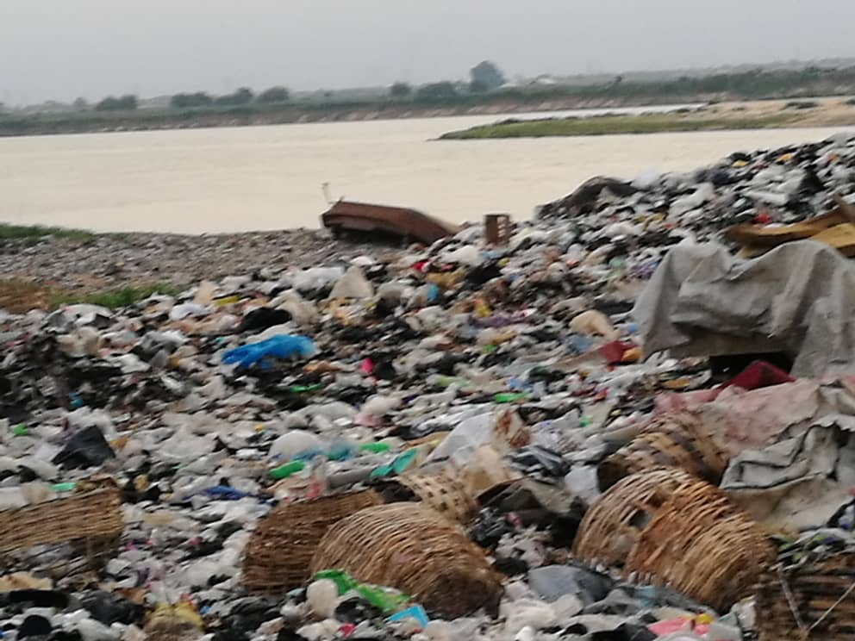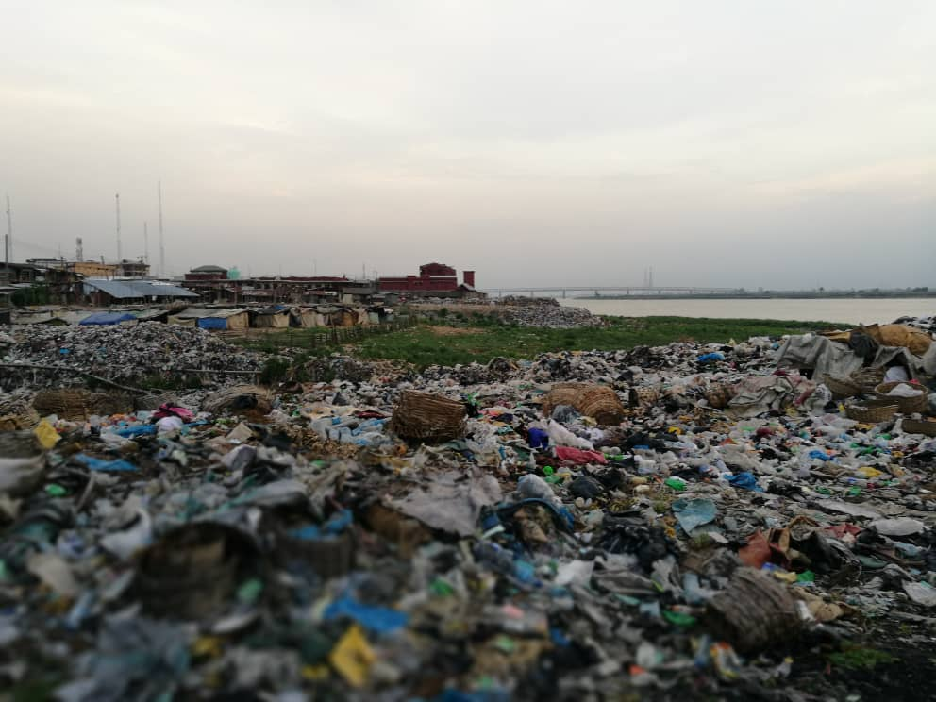
Fig. 8. Surface water dumps on the Niger River Fig. 9. Surface water dumps on the Niger River
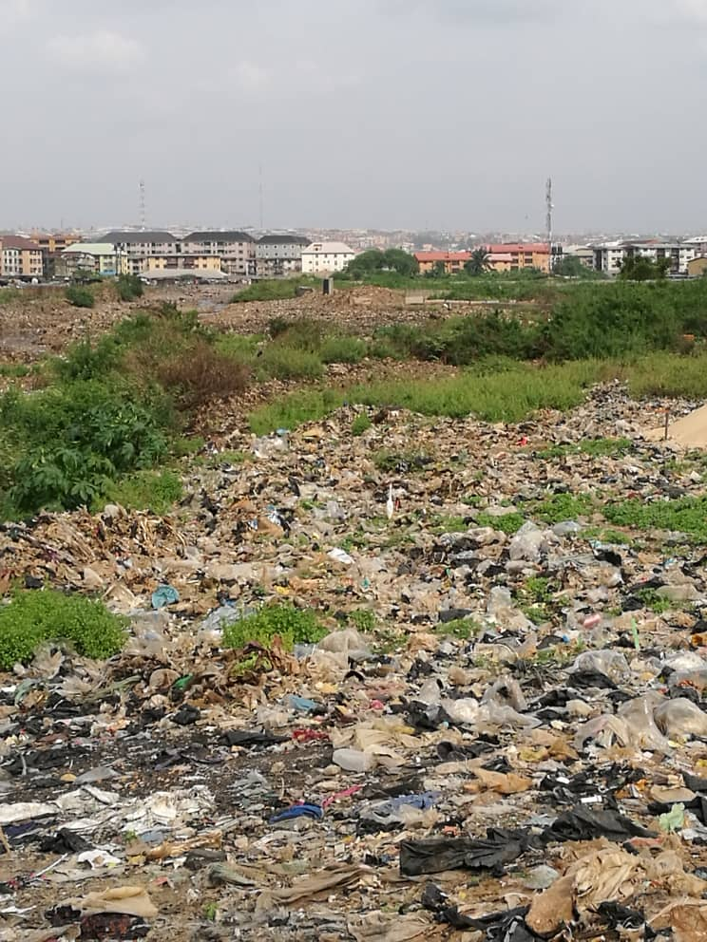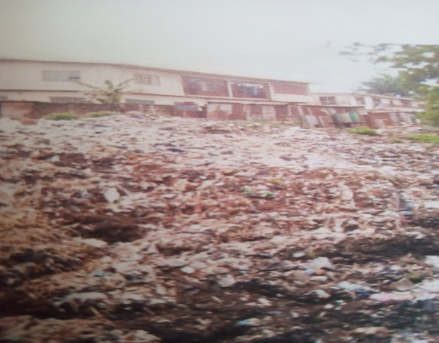
Fig. 10. surface water dumps on Nwengene creek Fig. 11. Okpoko Ground surface Dumpsite
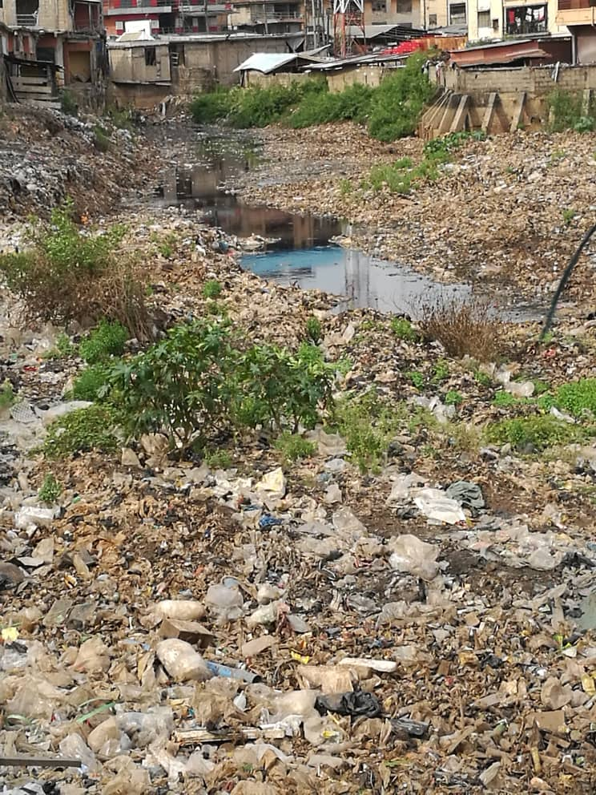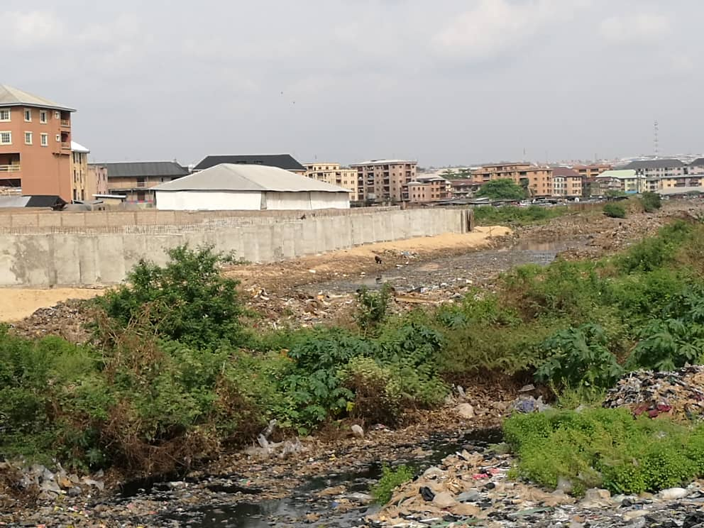
Fig. 12. Dumpsite at Nwengene creek- Bida Fig. 13. Dumpsite along Niger Street -Fegge

There is alternating sand/shale heterolith in Fegge is suggested by the zigzag nature of the curve. The results suggest a water level of 4m and the aquifer to be 7-10m and around 14-17m. These results were interpreted to suggest an auriferous unit between 40-80m, below which is a shally unit. At the Atani Road site, depth to aquifer is between 20-30m. The response of the subsurface to the receipt and release of current beyond 30m suggests the presence of a thick non-conductive shale/ or some artificial impediments.
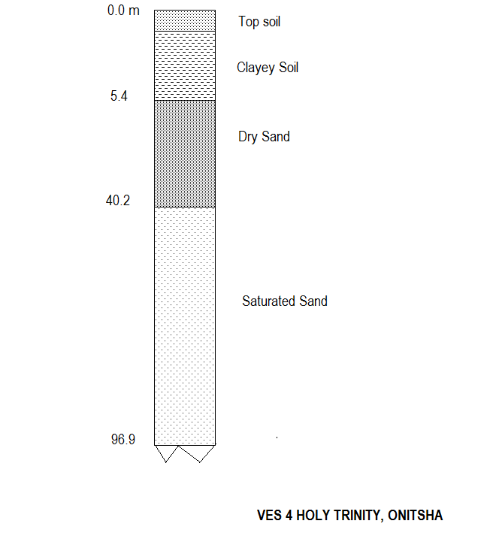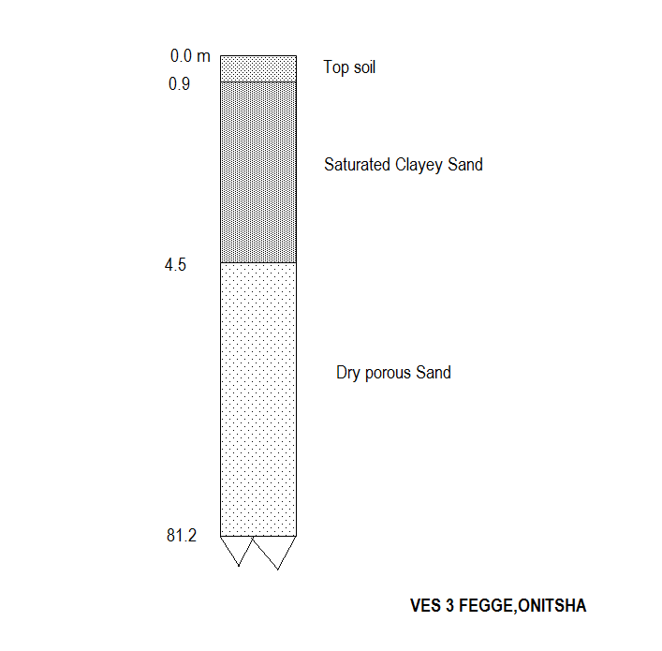
Fig. 14. Lithologs from VES survey Fig. 15. Lithologs from VES survey
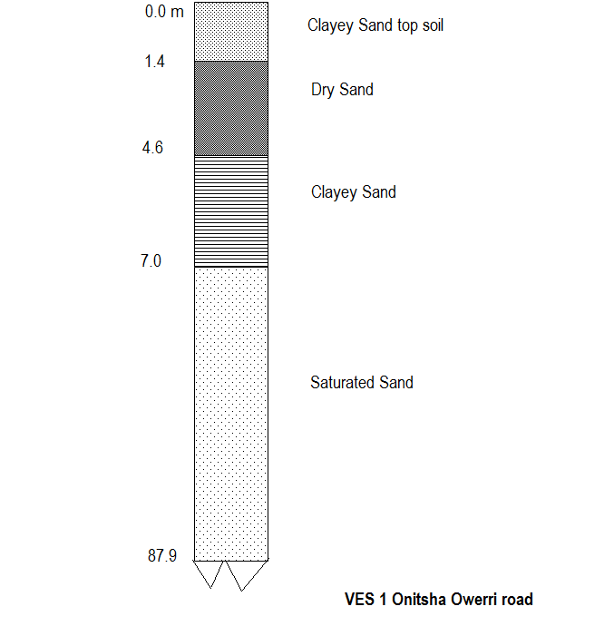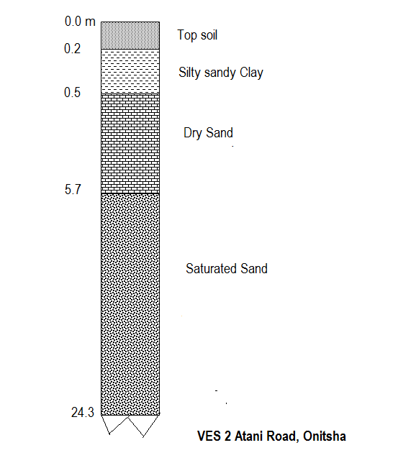
Fig. 16. Lithologs from VES survey Fig. 17. Lithologs from VES survey

The results of the VES near the Holy Trinity Catholic Cathedral Onitsha showed depth to aquifer around 70m. Above that there are alternations presenting high resistivity dry gravelly sandstone units alternating with low resistivity shales.
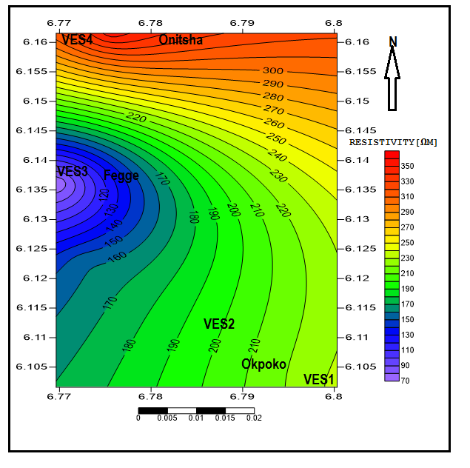
Fig. 18. The VES curves from the study area.

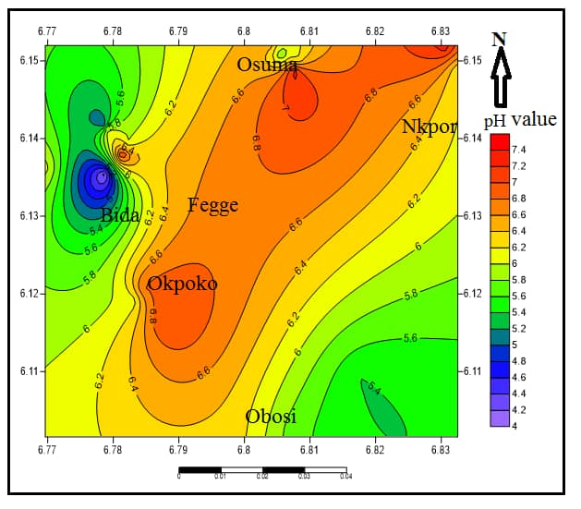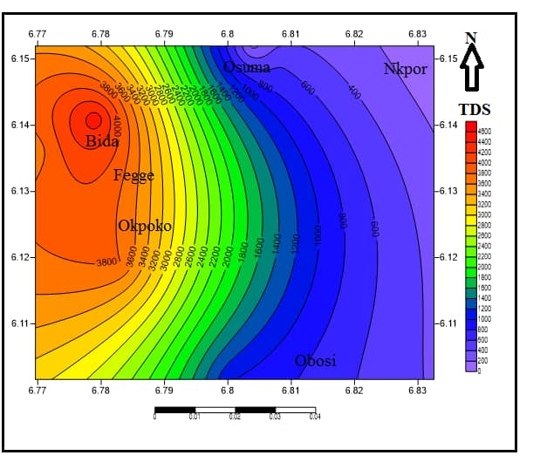
Fig.19. Spatial Variation map for pH Fig. 20. Spatial Variation map for TDS
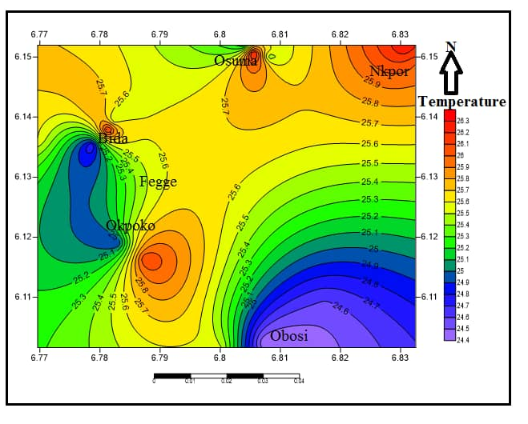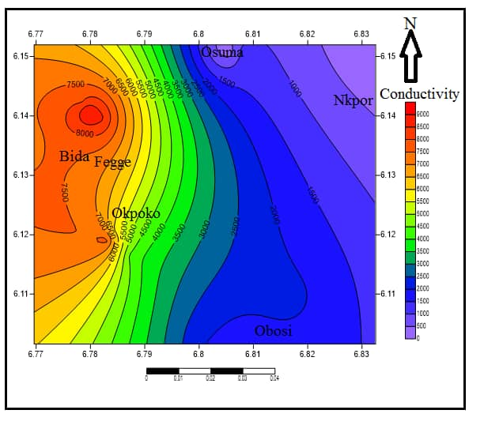
Fig.21. Spatial Variation map for Temp Fig.22. Spatial Variation map for Conductivity
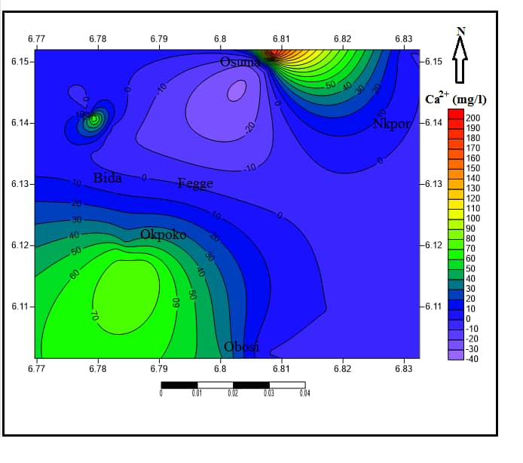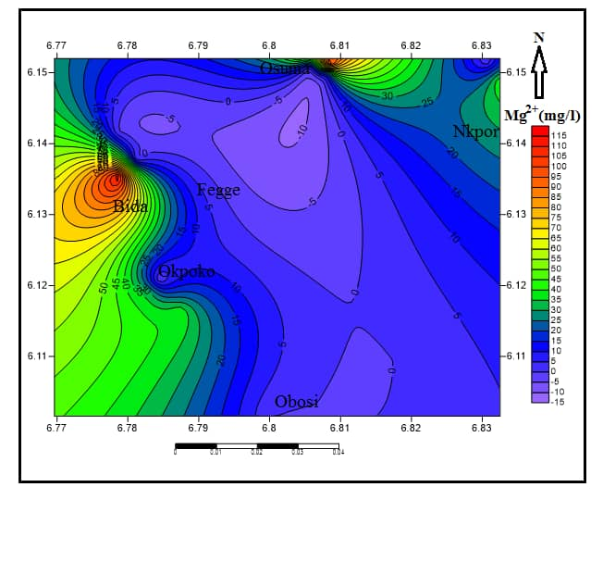
Fig. 23. Spatial Variation map for Ca²⁺ Fig.24. Spatial Variation map for Mg²⁺

Discussion and Integration of Findings
The TDS levels observed in most of the locations reading above 500-1000mg/l indicate quality problem. Conductivity is a measure of water sample’s ability to pass electric current which is a function of concentration of dissolved electrolyte ions in the water. The threshold limit for conductivity is 1000us/cm and levels’ exceeding the standard range is indicative of nutrient influx. The pH is an important operational water quality indicator. Low-pH water is more likely to be corrosive. The pH of the water entering the distribution system must be controlled to minimize the corrosion of water mains and pipes in household water systems. However, the fact that most of the samples were found to have acceptable pH values, does not mean that the groundwater is palatable.
When compared with the WHO recommended range for pH in drinking water (6.5-8.5), about 80% of the samples analyzed present values within the acceptable range, whereas the few remaining samples were slightly acidic. In general, acidic pH indicates the possible effect of contamination due to natural or anthropogenic sources or both.
It is a fact that large proportion of the metropolitan population of the study area rely on groundwater for their water supply. Also some of the water sources are not properly protected and the water untreated. Groundwater protection against pollution is considerably cheaper than mitigating polluted groundwater. This is because it is technically demanding, expensive, time-consuming and even impossible in some cases.
Protection of groundwater quality requires a combination of measures that target the water resource, the sources of pollution and the remedial actions.
To attain groundwater protection in Onitsha metropolis resource-focused, source-focused or remedial approaches may be required.
In order to achieve sustainable outcomes, these strategies must be approached in an integrated manner. These include: identification and mapping of sources of pollution; establishment of a database and information management system; development of groundwater vulnerability map; initiation of a monitoring network; establishment of protection zones; and promotion of public awareness and participation.
This study focused on indiscriminate dumping of wastes in unprotected locations which constitute problems to groundwater resources in the area. A combination of these strategies plus proper waste containment measures will minimize the index of groundwater quality impacts.
Groundwater contamination in an unplanned urban area may be difficult to model because the contaminants may originate from myriads of sources. Identifying these sources one by one is a problem on its own yet it is a prerequisite for effective management. Mapping groundwater pollutant sources in Onitsha metropolis is complex owing to the concept of decentralized groundwater development in practice. Since the fate of contaminants in the environment is dynamic, mapping groundwater contaminant sources must be updated regularly hence the need for this study and periodic studies of this nature. Also developing a central groundwater quality database and information management system in the region will serve to archive the outcomes these of the periodic studies for reference purposes and for monitoring of trends and patterns.

Analysis of Groundwater Vulnerability
Groundwater vulnerability mapping identifies aquifers that are susceptible to contamination by anthropogenic activities. Such maps can serve as instruments for the effective groundwater quality protection in peculiar circumstances. The waste management approach designate in Onitsha metropolis is unsustainable, this makes vulnerability mapping imperative. Doing this, equips the regulators and other stakeholders in the environmental protection project with a fundamental structure that will enhance implementation of pollution prevention and control measures in vulnerable areas in a more precise terms.
It will have hallowed application in urban development and land-use planning for activities including urban agriculture, waste management, and industrial operations requiring proper placement regarding the respective vulnerabilities of the host environment.
Secure landfills that do not allow leachate to occur or escape can be used to contain wastes in Buffer Zones, this landfill design has the potentials to drain leachates when they occur. They are eventually piped away from source and to a convenient place where they can be diluted before reintroduction into the environment. This is one of the most effective and reliable measures for controlling groundwater contamination. It employs the concept of time to allow for the attenuation of contaminant to delay its transportation from its source to repositories. Protection zones implies that the entire recharge areas around well-fields to be protected totally against any change in groundwater properties in order to preserve its natural qualities. But this approach has better adaptation in cities with centralized sewer, sewage and water service system. This means that Onitsha metropolis with decentralized water service and haphazard waste management approach cannot adapt this but desperately needs because it rely on groundwater for its water supply.
Hydrogeologically the groundwater aquifers in the study area are unconfined presenting sequence of sands and sand-rich clays which does not provide protection to the groundwater from surface contamination. This makes indiscriminate dumping of refuse on open surfaces, dumping of wastes in unprotected sites a crime as well as open burning of combustible wastes. This is because judging the geology and the hydrogeological features, only secure landfills should be employed in Onitsha.

Conclusion
Poor environmental sanitation leads to environmental pollution with attendant impacts water quality either directly or through intermediaries. Since hygiene and sanitation impacts water, it follows that manipulative handling of interface between water, waste and environment can enhance mitigation of water quality problems. The current author in an earlier work using analysis of variance traced parameters found in water samples to a common source which is landuse because in her studies, the coefficient of correlation matrix showed link between water, sanitation and health. Proper management of wastes of whatever class or kind will control nutrient influx from pollution. Networking the sewer system to ensure proper management is a sustainable approach to urban sewerage than the private sewer systems done without regulations on environmental protection.
There is strong relationship between water problems with spatial aspects of human activities (hygiene, environmental pollution and sanitation). This fact beckons for integrated management of land and water use by regulating human use of both resources for a sustainable future with such vital resources. Natural resources development should strike a balance with land use and water use, while controlling pollution as this will positively impact water quality.
The fresh water treaty and freshwater insurance will control environmental pollution from human activities so that the landuser takes responsibility for activities that pollute – waste disposal inclusive.

References
Adelana, S.M.A., Abiye, T. A., Nkhuwa, D.C.W., Tindinugaya C., and Oga, M. S.
(2008): Urban groundwater management and protection in Sub-Saharan Africa in: Adelana, S. M. A and MacDonald, A.M Applied Groundwater Studies in Africa, International Association of Hydrogeologists, selected papers. pp.222-259.
Agunwanba, J. C. (2003): Analysis of Scavengers‟ Activities and Recycling in Some
Cities of Nigeria. Environmental Management, 32(1): 116–127
Al-Khatib, I.A. (2007): Trends and problems of solid waste management in developing
countries: a case study in seven Palestinian districts. Waste Management, 27 (12), 1910–1919.
Binns, J. A., Maconachie, R.A. and Tanko, A.I. (2003): Water, land and health in urban
and periurban food production: The case of Kano, Nigeria. Land Degrad. Develop., (14): 431–444.
Elekwa, N.N. (2001): The concept of Developing and Industrial Societies and Emerging
Trends
in City Management’. In Ezeani and Elekwa (eds); Issues in Urbanization and Urban Administration in Nigeria. Enugu; Jamoe Enterprises.
Eni, D.V., Obiefuna J., Oko. C., and Ekwok I. (2011): Impact of Urbanization on Sub-
surface Water Quality in Calabar Municipalty, Nigeria. International Journal of Humanities and Social Sciences, Vol.1, Issue 10, pp.167-172.
Ezeabasili, A. C., Anike O. C., Okoro, B. U. and Dominic C. M. U. (2014): Arsenic
Pollution of Surface and Sub- surface Water in Onitsha, Nigeria. Africa Journal of Environmental sciences and technology. Vol 8(9) pp 491- 497, Sept. 2014.
Henry, R. K., Yongsheng, Z. and Jun, D. (2006): Municipal solid waste management challenges in developing countries – Kenyan case study. Waste Management, (26): 92–100.
Ibezue, V. C., (2013): Water Impact Index as a Function of Landuse. Journal of Applied Global Research
ISSN 1940-1833 JAGR-Volume 6, Issue 16(2013), Pp. 19-34. Ince, M. (2010): Rapid Assessment of Drinking Water Quality (RADWQ) – Country
Report of The Pilot Project Implementation in 2004-2005. World Health Organisation and UNICEF.
Kjeldsen, P. (2002): Present and long-term composition of MSW landfill leachate: a
review. Critical Reviews in Environmental Science and Technology, 32, 297e336.
Tatsi A and Zouboulis, A. (2002): A field investigation of the quantity and quality of
leachate from a municipal solid waste landfill in a Mediterranean climate (Thessaloniki, Greece). Advances in Environmental Research, 6(3): 207-219.
Vidanaarachchi, C. K., Yuen, S.T.S. and Pilapitiya, S. (2006): Municipal solid waste
management in the Southern Province of Sri Lanka: Problems, issues and challenges. Waste Management, 26, pp 920- 930.
WHO (2006): Protecting Groundwater for Health: Managing the Quality of Drinking-
water Sources. Edited by O. Schmoll, G. Howard, J. Chilton and I. Chorus. ISBN:1843390795. Published by IWA Publishing, London, UK. References 236

